Payment Recovery Agent- Set Up & Agent Journey
Segment 1- Setting Up the Agent
- Choose an agent: Clicks Payment Recovery

- Speak or type prompt: How many transactions failed this month?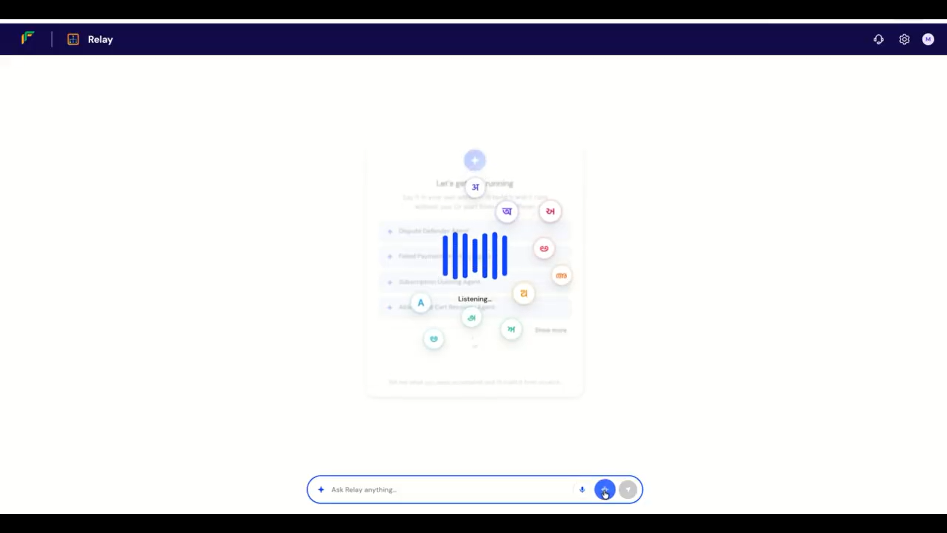
The agent lists failed transactions with reasons for failure.
Agent: Would you like to set up an agent to help recover them?
User: Yes, do that.
Agent: It’s done. Would you like to do a test run?
User: Yes, let’s do a test run
Agent reports test run successful. The Agent asks whether it should activate the Payment Recovery Agent. The user says yes.
Agent: Your Payment Recovery Agent is now live.
Segment 2- Cart Recovery
AT the shopify checkout, user receives notification/ message that payment failed

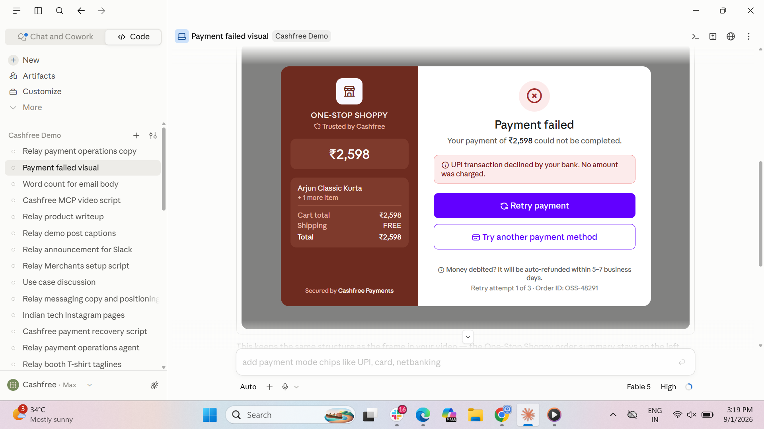
Segment 3: Agent Reaches out to buyer on call
Phone call UI mockup
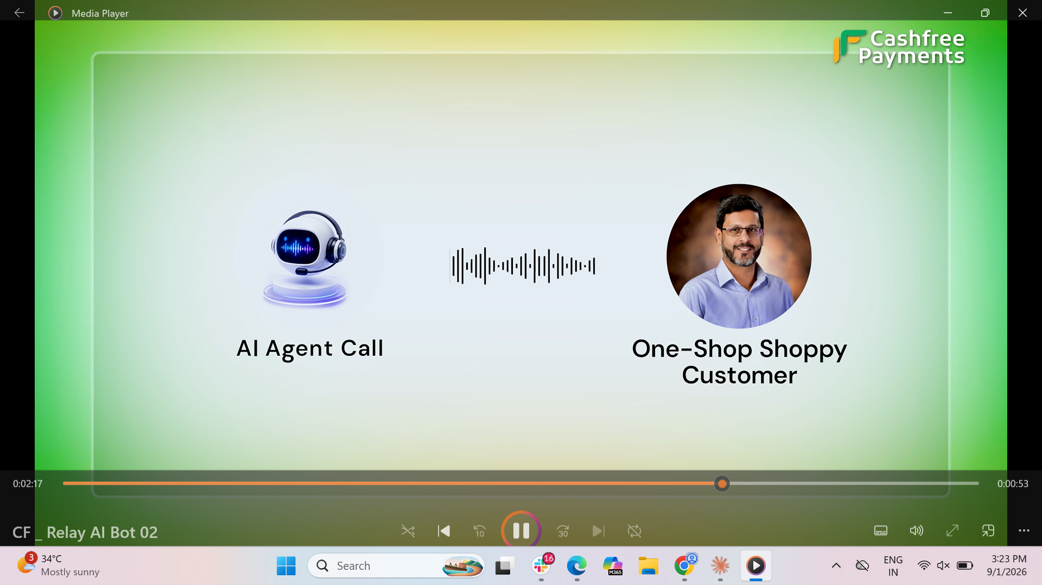
Agent: Hi ABC, I noticed your payment didn’t go through earlier.Your bank was facing a temporary issue. Would you like to try again?
Buyer: Yes
Agent: Here's the payment link. We recommend using UPI for the payment.
Buyer: Customer clicks the link, makes the payment. Payment successful tick appears.

